Course Name: Advanced Programming (PCCCS495)

Project Title: Online Quiz Engine Using Factory Pattern for Question Types
Student Name: Ritwika Banerjee
Roll Number: 28

Instructor Name: Dr. Susovan Jana,
Dr. Soumadip Biswas, Dr. Swagatam Basu

Term: Spring 2026

Problem Statement:
Many quiz systems are designed in a rigid way where adding new types of questions requires modifying existing code, making the system difficult to maintain and extend. Educational platforms often require quizzes with different formats such as multiple-choice, true/false, and short-answer questions. The proposed Online Quiz Engine solves this problem by using Object-Oriented Programming principles and the Factory Design Pattern to dynamically create different question types. The system supports multiple question formats while maintaining a flexible and scalable structure. Abstraction, inheritance, and polymorphism allow different question types to be handled uniformly, while collections manage questions dynamically and exception handling ensures reliable user interaction.
System Design:
UML Class Diagram
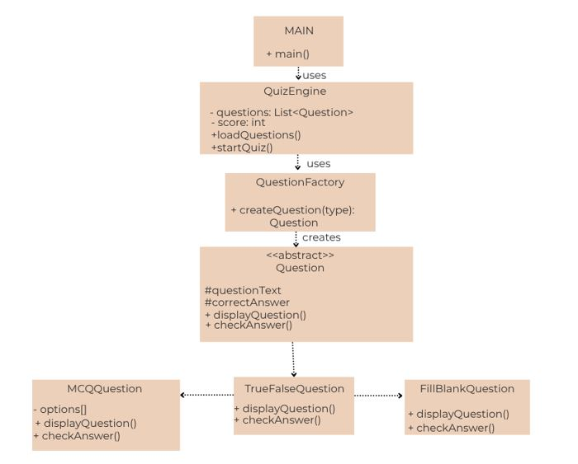
Major Classes Description:
1. Main Class
The Main class serves as the entry point of the application. It initializes the QuizEngine and starts the quiz execution. It also contains basic exception handling to ensure the program runs safely in case of unexpected errors.
2. Question (Abstract Class)
The Question class is an abstract base class that defines the common structure and behavior for all question types in the quiz system. It contains attributes such as the question text and correct answer, and declares abstract methods like displayQuestion() which must be implemented by all subclasses. This class demonstrates abstraction.
3. MCQQuestion Class
The MCQQuestion class represents multiple-choice questions. It extends the abstract Question class and includes additional attributes for storing the answer options. It overrides the displayQuestion() method to display the question along with its available options.
4. TrueFalseQuestion Class
The TrueFalseQuestion class represents questions that have only two possible answers: true or false. It inherits from the Question class and implements the specific logic required to display and evaluate true/false answers.
6. QuestionFactory Class
The QuestionFactory class implements the Factory Design Pattern. It is responsible for creating different types of question objects based on the requested question type. This helps decouple object creation from the rest of the program and makes it easier to add new question types in the future.
7. QuizEngine Class
The QuizEngine class manages the overall quiz workflow. It loads questions using the QuestionFactory, stores them in a collection, displays each question to the user, collects responses, checks answers, and calculates the final score.
Package Structure:
src
│ ──> Main.java
│ ──> Question.java
│ ──> MCQQuestion.java
│ ──>TrueFalseQuestion.java
│ ──> FillBlankQuestion.java
│ ──> QuestionFactory.java
│ ──> QuizEngine.java
Interaction Flow:
The interaction flow of the Online Quiz Engine describes how different components of the system communicate with each other during quiz execution.
- The program starts from the Main class, which acts as the entry point of the application.
- The Main class creates an instance of the QuizEngine class and initiates the quiz process.
- The QuizEngine calls the loadQuestions() method to load quiz questions.
- Inside this method, the QuestionFactory is used to dynamically create different types of question objects such as MCQQuestion, TrueFalseQuestion, and FillBlankQuestion.
- The created question objects are stored in a collection using ArrayList<Question>, allowing dynamic storage and easy iteration.
- The QuizEngine then starts the quiz by displaying each question to the user one by one using the displayQuestion() method.
- The user enters their answer through the console, which is captured using the Scanner class.
- The answer is evaluated using the checkAnswer() method implemented by each specific question type.
- If the answer is correct, the score is increased; otherwise, the program proceeds to the next question.
- After all questions are answered, the QuizEngine calculates and displays the final score to the user.

OOP Concepts Demonstrated:

1. Abstraction

Where it is used
Abstraction is implemented using the abstract class Question, which defines common properties and behavior shared by all question types.

Why it is used
It hides implementation details of different question types while providing a common structure for them. This allows the quiz engine to interact with different questions in a uniform way.

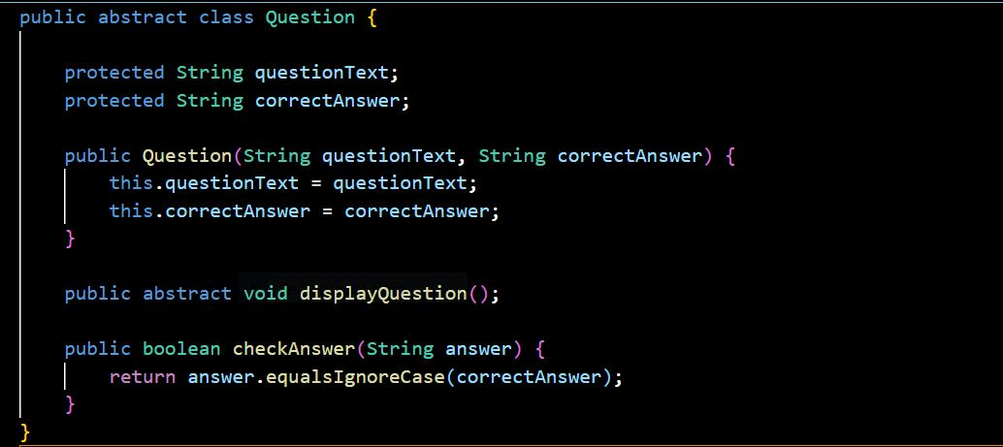
The Question class is declared as abstract because it provides a general template for all question types but should not be instantiated directly. The abstract method displayQuestion() forces all subclasses to provide their own implementation.

2. Inheritance
Where it is used
Classes such as MCQQuestion, TrueFalseQuestion, and FillBlankQuestion inherit from the abstract Question class.
Why it is used
Inheritance allows subclasses to reuse properties and methods defined in the parent class, reducing code duplication and improving maintainability.
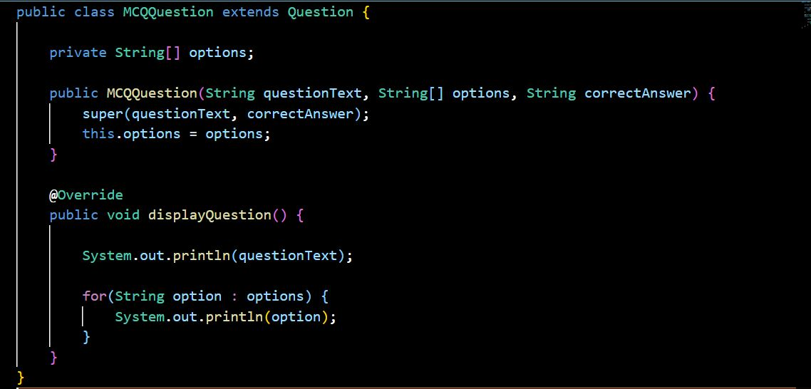
The MCQQuestion class extends the Question class and inherits its attributes such as questionText and correctAnswer. It also provides its own implementation of the displayQuestion() method.

3. Polymorphism
Where it is used
Polymorphism is used when different types of question objects are stored and handled using the common type Question.
Why it is used
It allows the quiz engine to treat different question types uniformly while each class implements its own behavior.
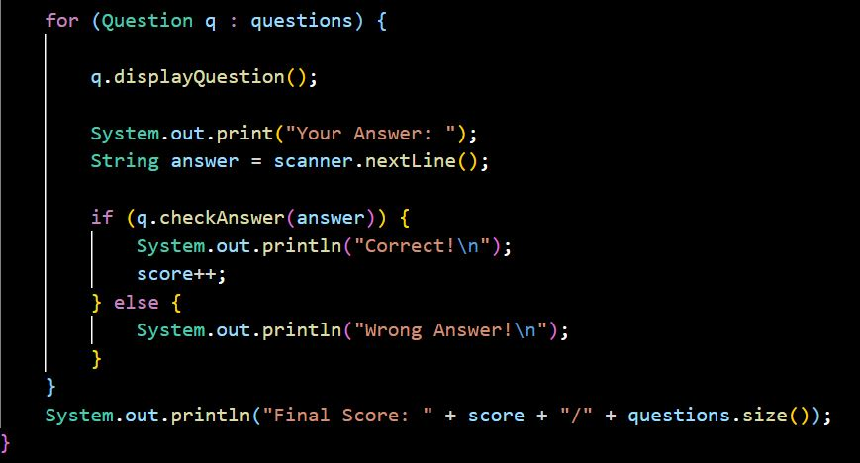
Although questions may contain objects of different subclasses such as MCQQuestion or TrueFalseQuestion, they are handled using the base class Question. Each object executes its own version of displayQuestion() and checkAnswer().

4. Encapsulation
Where it is used
Encapsulation is applied in the QuizEngine class where data such as the list of questions and the score are kept private.
Why it is used
Encapsulation protects the internal data of the class and prevents direct modification from outside the class.
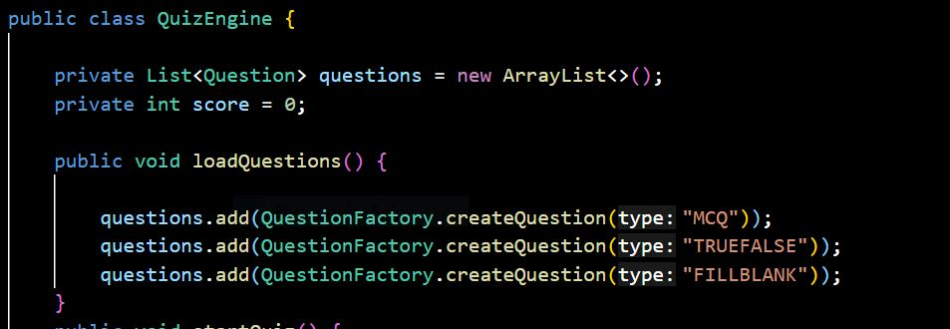
The variables questions and score are declared as private, meaning they cannot be accessed directly outside the class. The class controls how this data is used through its methods.

5. Exception Handling
Where it is used
Exception handling is used in the Main class to ensure that the program handles runtime errors gracefully.
Why it is used
It prevents the application from crashing due to unexpected errors and allows the system to display an appropriate error message.
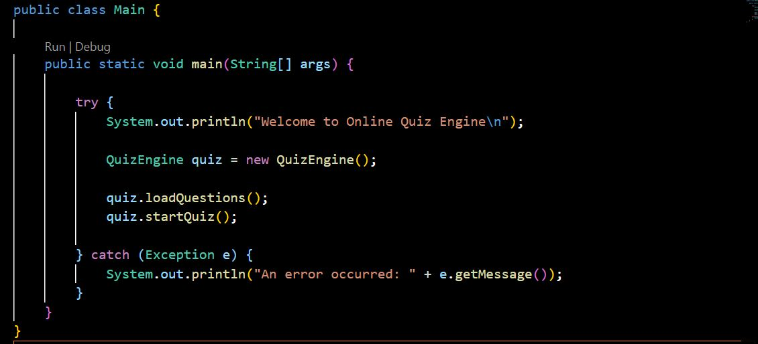
The quiz execution is placed inside a try-catch block. If an unexpected error occurs during execution, the program catches the exception and displays an error message instead of terminating abruptly.
6. Collections
Where it is used
Collections are used in the QuizEngine class to store multiple questions dynamically.
Why it is used
Collections such as ArrayList allow flexible storage and easy iteration through quiz questions.
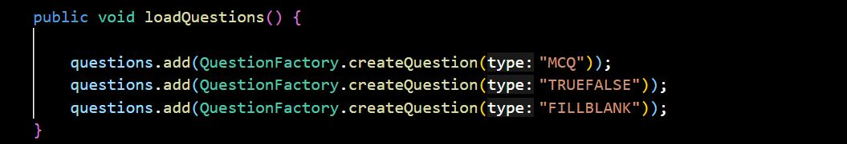
The ArrayList stores different question objects dynamically. This allows the system to add, remove, or iterate through questions easily during quiz execution.
Implementation Highlights:
- Factory Pattern for Creating Question Objects
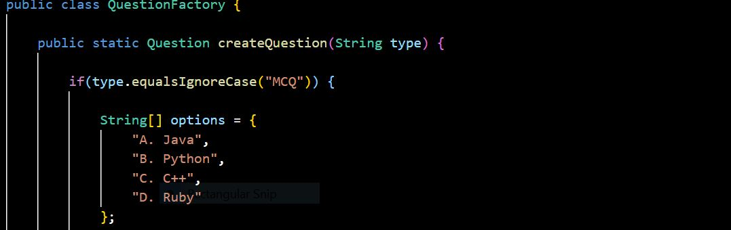
Justification
This snippet shows the use of the Factory Design Pattern to create question objects dynamically. Instead of directly creating objects throughout the program, the factory centralizes object creation. This improves code maintainability and makes it easier to add new question types in the future.
- Storing Questions Using Collections
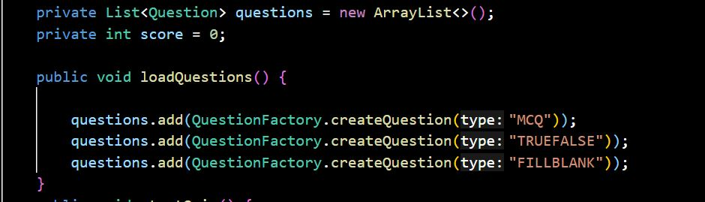
Justification
This snippet demonstrates the use of Java Collections. The ArrayList allows dynamic storage of multiple question objects and enables the quiz engine to iterate through them easily during quiz execution.
- Evaluating User Answers
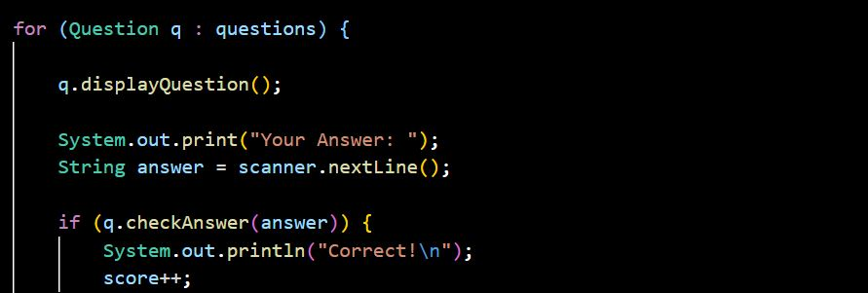
Justification
This snippet represents the main quiz execution logic. Each question is displayed, the user provides an answer, and the system checks the response using the checkAnswer() method. This also demonstrates polymorphism, as different question types respond to the same method call in their own way.
Testing & Error Handling:
Test Cases Considered
To verify the correctness of the Online Quiz Engine, several test cases were executed to ensure that different question types function correctly and that the system evaluates answers accurately.
Test Case Input Given Expected Result
Correct MCQ Answer A Correct
Incorrect MCQ Answer | B | “Wrong Answer”

Correct True/False Answer | True | System marks answer as correct
Incorrect True/False Answer | False | System marks answer as incorrect
Edge Cases Handled
- Empty Input: If the user submits an empty answer, the system treats it as incorrect and continues to the next question.
- Case Sensitivity: Answers are compared using case-insensitive matching so inputs like "java" and "Java" are accepted as the same.
- Invalid Option: If the user enters an option other than the expected choices (e.g., A/B/C/D), the program continues without crashing.
Failure Scenarios
- Runtime Errors: The program uses try-catch blocks to handle unexpected errors during execution.
- Invalid Inputs: Incorrect or unexpected inputs are handled safely so that the quiz continues running without terminating.

Git Workflow:

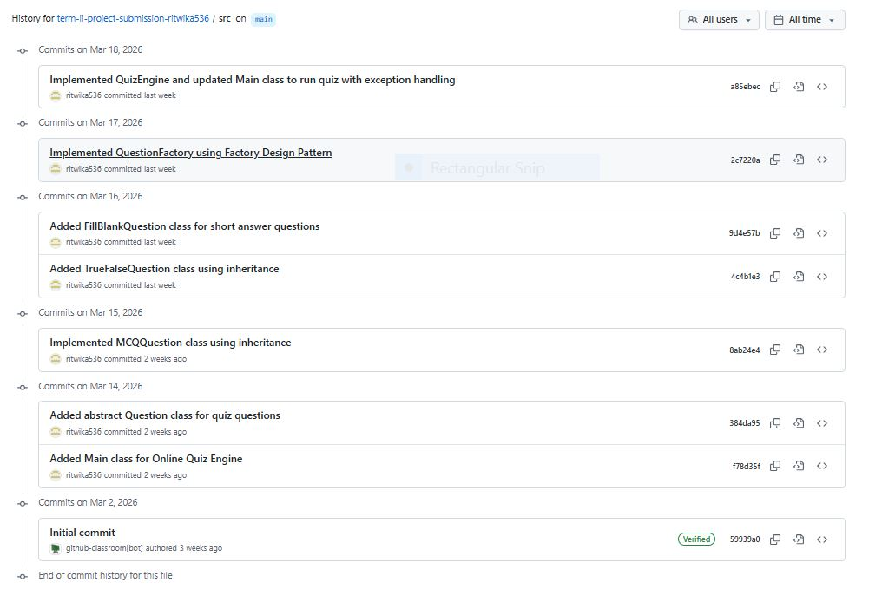

Development progression:

The development of the Online Quiz Engine was carried out incrementally using version control on GitHub. The first stage of development involved creating the Main class, which serves as the entry point of the application and is responsible for initializing and running the quiz engine. After establishing the basic program structure, the abstract Question class was implemented to define the common structure and behavior for all question types. This step introduced abstraction into the project and laid the foundation for implementing different question subclasses such as multiple-choice, true/false, and fill-in-the-blank questions. The commit history reflects a structured development process where the core architecture was established first before expanding the functionality of the quiz system.
Conclusion & Future Scope:
The Online Quiz Engine demonstrates the effective use of Object-Oriented Programming concepts such as abstraction, inheritance, polymorphism, and encapsulation along with the Factory Design Pattern. The system provides a modular and extensible structure for handling different types of quiz questions while maintaining clean and maintainable code.
In the future, the project can be enhanced by adding a graphical user interface, implementing a quiz timer using multithreading, loading questions from external files or databases, and supporting larger quizzes with more advanced features such as result tracking and performance analysis.
APPENDIX:
PROJECT PROPOSAL:
Project Title: Online Quiz Engine Using Factory Pattern for Question Types
Problem Statement:
Many quiz systems are designed in a rigid way where adding new types of questions requires modifying existing code, making the system difficult to maintain and extend. Educational platforms often require quizzes with different formats such as multiple-choice, true/false, and short-answer questions. Without a flexible design, managing these variations becomes complex and leads to code duplication. The proposed Online Quiz Engine addresses this problem by using Object-Oriented Programming principles and the Factory Design Pattern to dynamically create different types of questions. The system allows quizzes to contain multiple question formats while maintaining a clean and scalable structure. By using abstraction, inheritance, and polymorphism, the engine can process different question types uniformly. Exception handling ensures reliability during user interaction, while collections manage quiz questions dynamically. This approach creates a flexible, maintainable, and extensible quiz system suitable for educational applications.
Target User :
1. Students taking online quizzes for learning or assessment
2. Teachers or instructors creating quizzes
3. Educational platforms or training systems
Core Features :
- Create quizzes containing multiple types of questions
- Support different question formats (MCQ, True/False, Short Answer)
- Dynamically create question objects using the Factory Pattern
- Display quiz questions and collect user answers
- Automatically evaluate answers and calculate scores
- Handle invalid inputs and incorrect selections
- Store and manage quiz questions dynamically using collections
OOP Concepts to be Used :
Abstraction
An abstract class Question will define common attributes and methods such as displayQuestion() and checkAnswer(), hiding the specific implementation details of each question type.
Inheritance
Different question types such as MCQQuestion, TrueFalseQuestion, and ShortAnswerQuestion will inherit from the abstract Question class and extend its behavior.
Polymorphism
The method checkAnswer() will be overridden in each subclass so that each question type evaluates answers differently while being handled uniformly by the quiz engine.
Exception Handling
Exception handling will manage issues such as invalid question types, incorrect answer formats, or invalid option selections using try-catch blocks and custom exceptions.
Collections / Threads (if applicable)
The system will use ArrayList<Question> to store quiz questions dynamically. Optionally, threads can be implemented to support quiz timers or countdown features.
Proposed Architecture Description :
The system will follow a layered architecture consisting of a User Interface layer, a Business Logic layer, and a Data Management layer. The UI layer handles user interaction, displaying questions and collecting answers through a console interface. The Business Logic layer, implemented by the Quiz Engine, manages quiz execution, answer evaluation, and score calculation. The Data layer stores and retrieves questions using collections. A Question Factory is used to create different question objects dynamically based on the requested type, ensuring loose coupling and easy extensibility. This architecture keeps the system modular, maintainable, and scalable.
Approved mail:
Dear Ritwika Banerjee,
Project: Online Quiz Engine Using Factory Pattern for Question Types
Decision: APPROVED_MINOR
Score: 88
Strengths:
The proposal clearly identifies a common problem in quiz systems and proposes an elegant solution using the Factory Design Pattern to achieve extensibility and maintainability. It effectively leverages core OOP principles like inheritance, polymorphism, and abstraction, which are central to the problem's solution. The layered architecture is well-defined, and the features list is comprehensive and appropriate for a university-level project. The use of collections for dynamic management and exception handling for robustness further strengthens the design.
Improvements:
The inclusion of 'Threads' as a core OOP concept to be applied is not clearly justified or elaborated within the problem description, features, or architecture. For a console-based quiz engine, its application might be minimal or unnecessary; clarification on its intended use (e.g., for background processing, concurrent quiz sessions, or complex timing mechanisms) or removal is recommended. Additionally, while not explicitly required by the prompt, mentioning unit testing as a key aspect for ensuring the correctness and maintainability of the different question types and evaluation logic would further strengthen the proposal.
Regards,
Course Instructor

